Java Interview Questions

Questions based on oops
- What is oops? Why is oops concept important in programming?
- What is encapsulation? How do we encapsulate or hide the data?
- What is the role of this keyword?
- What is the difference between local variable and instance variable?
- What is the difference between “this” and “super” keyword?
- What is the role of final keyword in java?
- What are the different access modifiers in java?
- What is difference between static block and instance block in java?
- What is a static block? What is the use of a static keyword?
- What is inheritance? Why is the inheritance required?
- How many types of inheritance supported by java?
- What is the role of super keyword?
- Is multiple inheritance possible in java?
- What is polymorphism? Why is the polymorphism required?
- What is the difference between overloading and overriding?
- Can we override static methods? If no then why?
- Can we override final methods? If no then why?
- What is the difference between compile-time polymorphism and runtime polymorphism?
- What is abstraction? How do we achieve abstraction in java?
- What is the difference between abstract class and interface?
- What is association? What is difference between composition and aggregation?
- What is immutable class? How to make any class immutable?
- What is singleton class? Why singleton design pattern is used?

Questions based on Exception Handling
- What is an exception? How to handle exceptions?
- Explain the exception handling classes and interfaces hierarchy in java?
- What is difference between Error and Exception?
- What is the difference between checked and unchecked exceptions?
- What are the different keywords used in exception handling? Explain them?
- Explain the Hierarchy of exception handling API in java?
- What is the difference between “throw” and “throws”?
- Can we use “try” without the “catch” block? If yes then what problem may happen?
- Why the “finally” block is used?
- How to make custom exceptions in java?
- What is the condition in try block that stops the execution of finally block?

Questions based on Multi-Threading
- What is Thread in java?
- What is multithreading? How do we implement multithreading in java?
- What is synchronization? How to do synchronization in java?
- What do you mean by thread safe? How synchronization is used to make thread safe?
- What is a volatile keyword?
- What do you mean by “lock” or “thread-safe” or “synchronization” in multithreading?
- What is Inter Thread communication? How do we implement this concept?
- What is Producer/Consumer problem in multithreading?
- What is thread life cycle? Explain?

Questions based on Collection Framework
- What is the difference between array and collection?
- Draw and explain collection framework hierarchy?
- What are the difference between Comparable and Comparator interface?
- What is the difference between ArrayList and LinkedList?
- What is the difference between ArrayList and Vector?
- What is Diff between Hashset and Treeset?
- What is difference between Enumeration and Iterator interface?
- What is difference between Iterator and ListIterator?
- What is the difference between List and Set?
- How does a Hashmap work internally?
- What is the role of hascode() and equals() method in HashMap?
- Can we used Collections class to sorting in Hashset?
- What is difference between HashMap and HashTable?
- What is the generics in Collection?
- What is the difference between Fail-Safe and Fail-Fast operation?
- What is “Queue”? When & why queue is used for implementation?

Question: Suppose we have a list like-
List<Integer> list = Arrays.asList(5,5,4,4,4,4,4,4,4,4,3,3,3,3,2,2,2,2,2);
do the following operation
- Find the occurrences of each number.
- Remove the duplicates numbers or Strings from the list.
- Sort and display like-
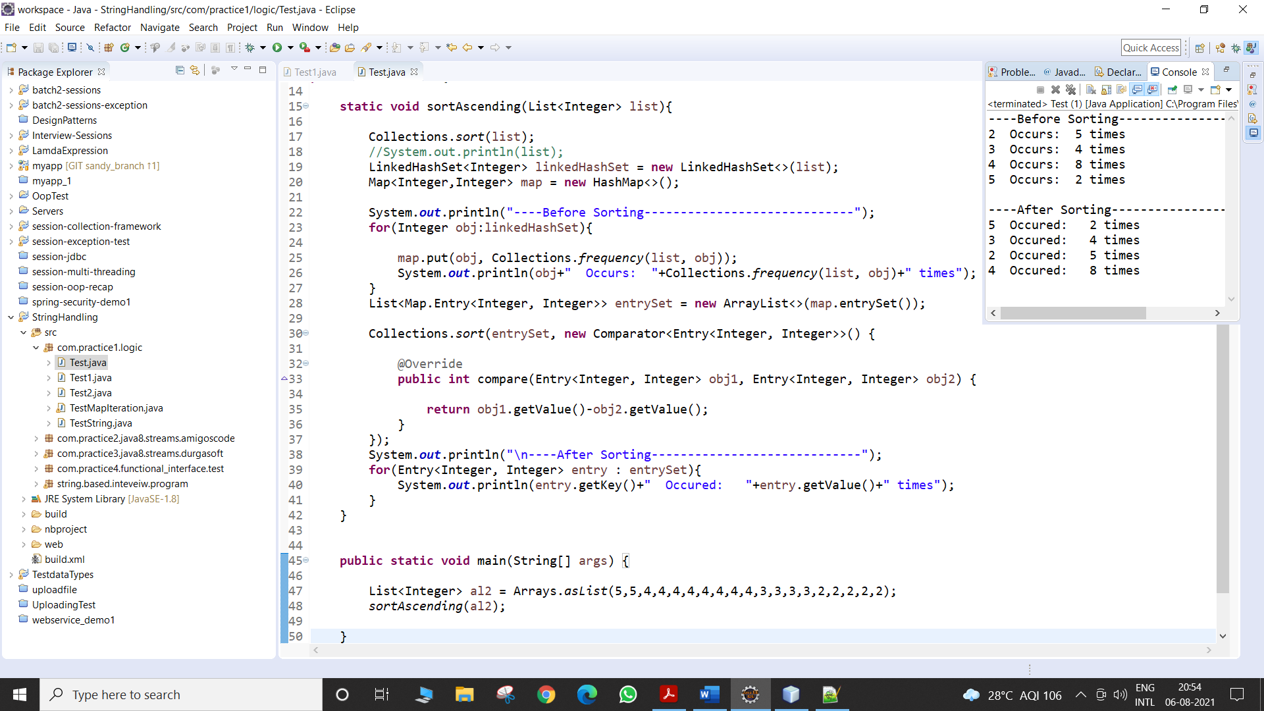

Questions based on String Handling
- Why is string immutable?
- Diff between String and StringBuffer?
- Diff between StringBuffer and StringBuilder?
- What is String constant pool (SCP)? What is the difference between String literal and String Object?
- How do we do reverse of any String? How can we make any string palindrome?

Question: Suppose we have following strings
String str1 = "I am am is king king of of of thailand";
String str2 = "rajaram roy was a good man";
do the following operation
- Occurrences of string along with sorting order of the string like screenshot.
- Occurrences of character along with sorting order of the character like screenshot.

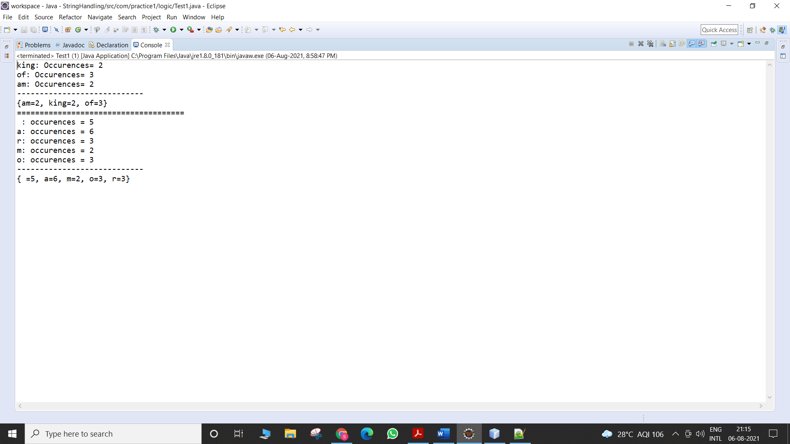

Question: Suppose we have following strings
String str = "aaabcdddddefgggggghijjjjjjjkklnnnno";

Then do the following operation like

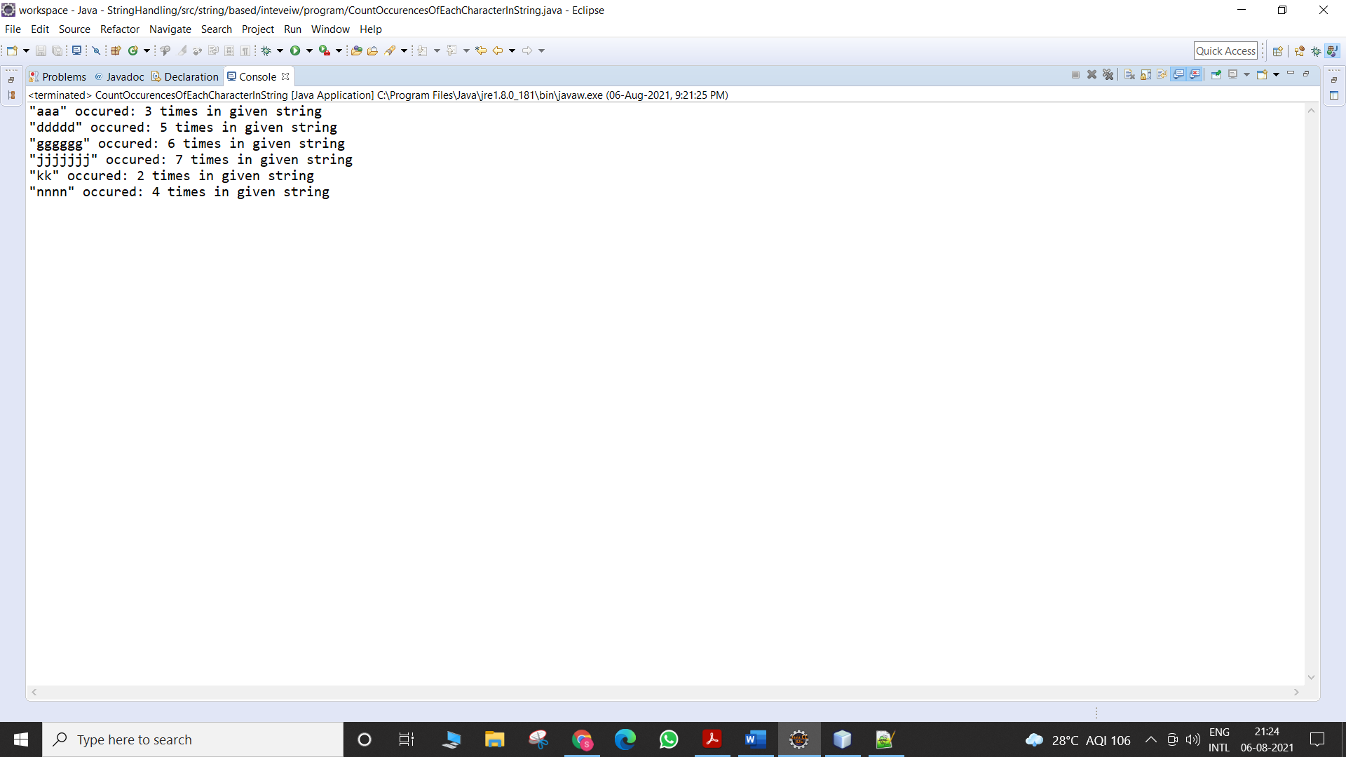

Questions based on JDBC
- What is JDBC in java? Explain java database connectivity steps?
- What is the role of driver in jdbc?
- Difference between Statement vs PreparedStatement vs CallableStatement?
- What are the four types of drivers used in jdbc? Compare type 1, type 2, type 3, type 4 drivers?
- What is the role of DriverManager class in jdbc?
- What is the role of ResultSet interface in jdbc?
- What are the different type of interfaces and classes used in jdbc?
- When to use execute(), executeUpdate(), executeQuery() method in jdbc?

Questions based on Servlet
- What is the Servlet? Explain servlet life cycle?
- What is server or web container?
- Compare HttpServlet v/s GenericServlet v/s Servlet?
- What are difference between HttpServlet and GenericServlet?
- Difference between ServletConfig and ServletContext?
- What are the different servlet scopes available in servlet? How they are differ with eachother?
- What is role of getRequestDispatcher() method in servlet? How is this different from sendRedirect() method?
- What is filters?
- What is listeners?

Questions based on JSP
- What is the difference between Servlet and JSP?
- How JSP life cycle is differ with Servlet life cycle?
- What are the JSP elements? What is difference between JSP directive include and JSP action include?
- What is the JSP implicit objects?
- What is the role of JSP scopes in action elements?

